1.Write a pig script to find the top 20 destination people travel the most: Based on the given data  
  
RUNNING PIGSCRIPT

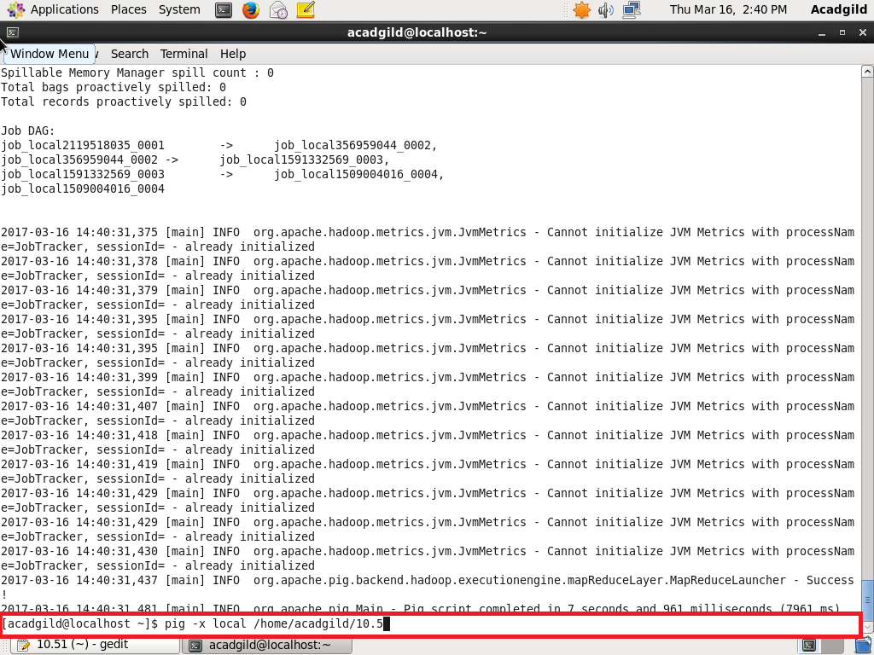

INPUT PIGSCRIPT AND OUTPUT

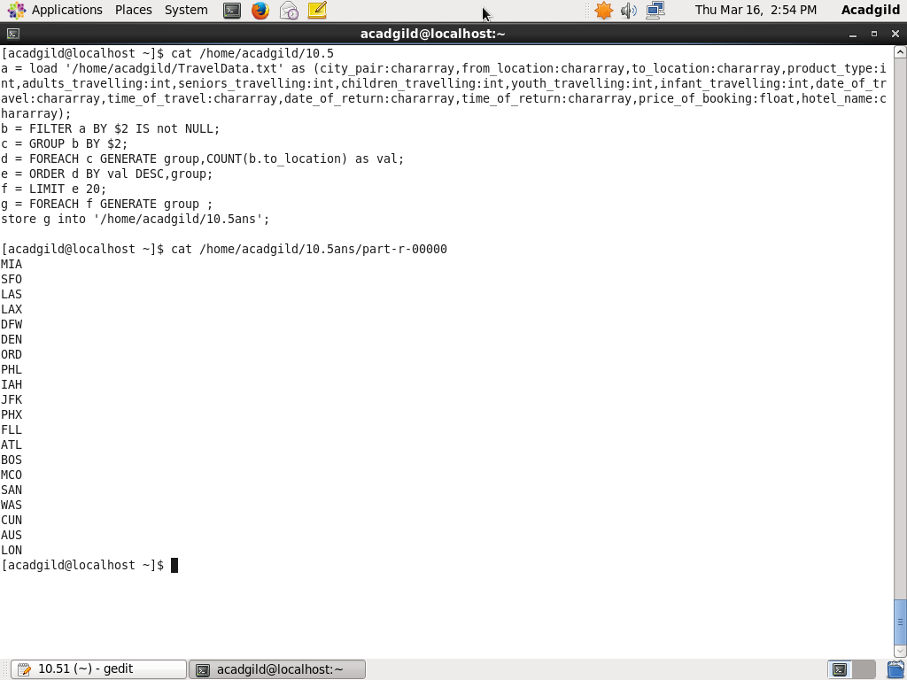

2. Write a pig script to find the top 20 locations from where people travel the most

INPUT PIGSCRIPT AND OUTPUT

